1. **Introduction:** In this lab, we learnt about the amplitude modulation, and demodulation of voice signal.

2. **Warm up:**

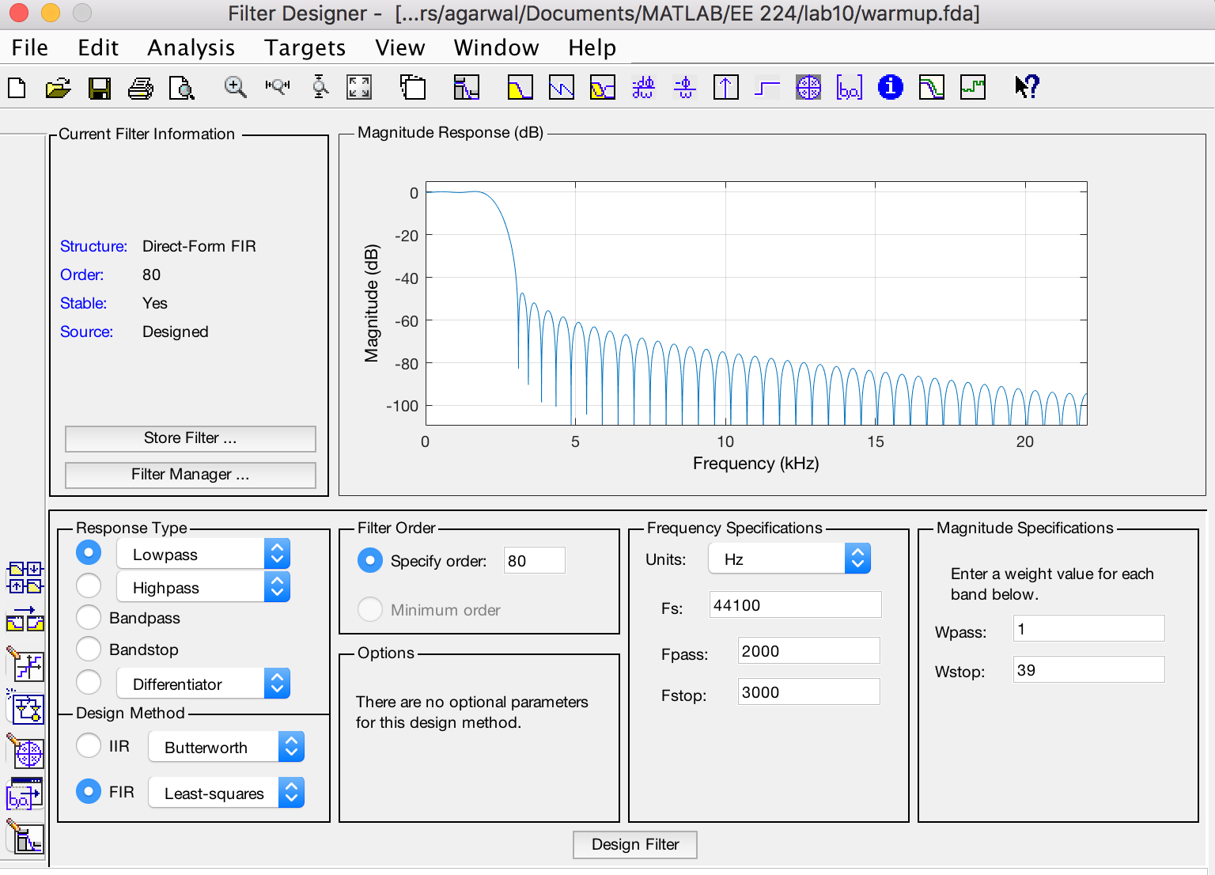

Original Recorded Voice:

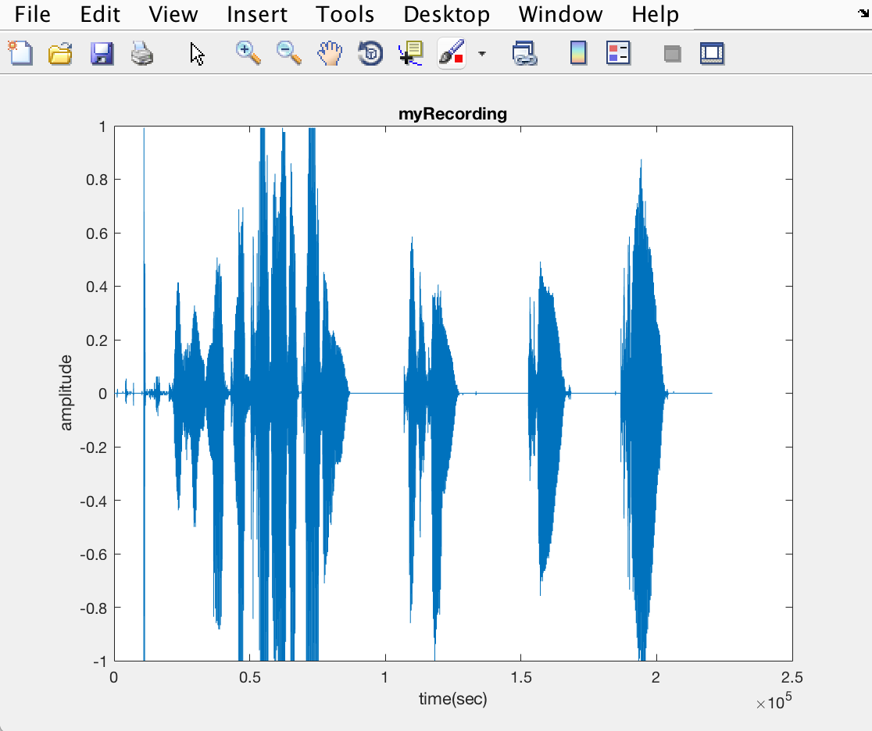

Filtered Recorded Voice:

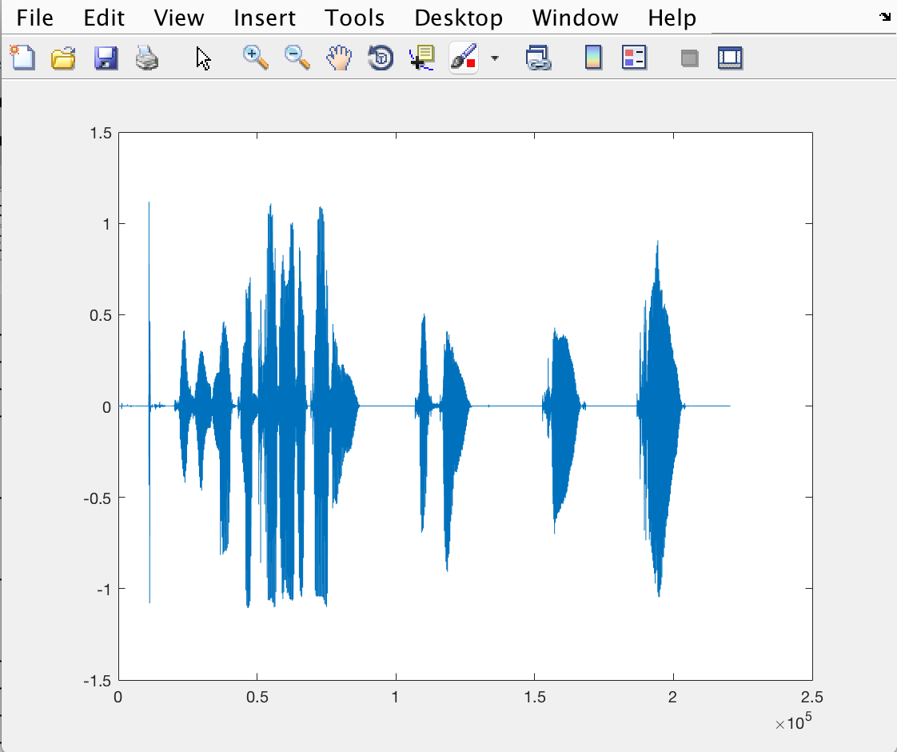

Spectrogram:

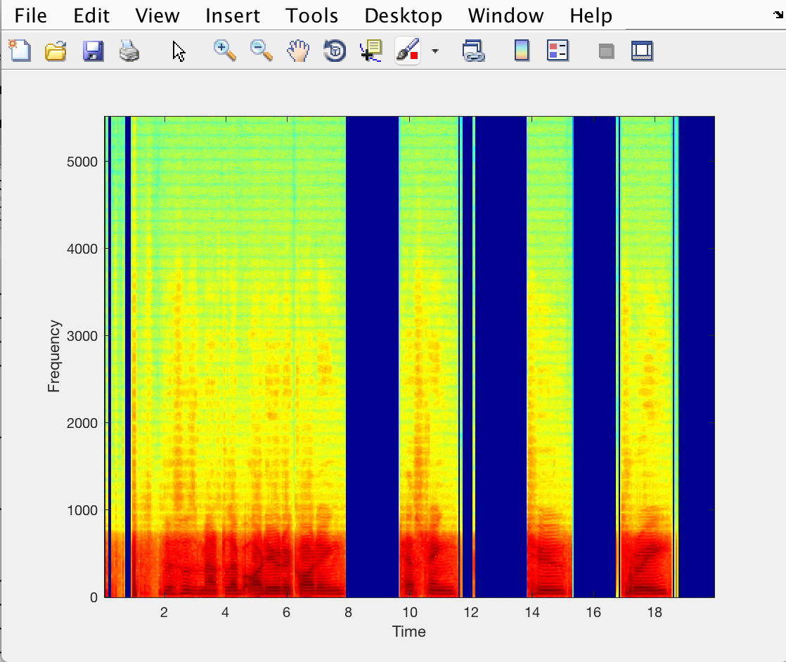

3. **AM Communication System**

Input Voice Signal:



Filtered Voice:



Spectrogram:



MATLAB Code for AM signal:

% Record your voice for 5 seconds.

recObj = audiorecorder(44100,8,1);

disp('Start speaking.')

recordblocking(recObj, 5);

disp('End of Recording.');

% Play back the recording.

play(recObj);

% Store data in double-precision array.

myRecording = getaudiodata(recObj);

% Plot the waveform.

plot(myRecording);

title('myRecording');

xlabel('time(sec)');

ylabel('amplitude')

% Define the sampling frequency in Hz

fs = 44100;

len = 1; % length of signals in seconds

t = (-len/2):1/fs:(len/2); % time index

m = myRecording

fc = 8000; % carrier frequency

c = cos(2*pi*fc*t);

% Modulate the signal

u = m.*c;

am_plot(t,m,c,u,1.1);

% Calculate the spectra

M = am_spectrum(m);

C = am_spectrum(c);

U = am_spectrum(u);

% frequency index for plotting

f = (-fs/2):(1/len):(fs/2);

% plotting them in frequency

am_plot(f,M,C,U,0.1);

3.1 **Explanation**:

The following is my homework explanation for the derivation of Figure 1.

